Chicago Tribune
November 24, 2002
Series: THE CHICAGO CRIME. First in a series.
Chicago's tolerance for murder
Edition: Chicagoland Final
Section: Editorial
Page: 10

Article Text:
On a pleasant Tuesday evening in late July, enraged bystanders beat to death Jack Moore and Anthony Stuckey after their van veered off Lake Park Avenue and injured three young women. The killers used strong hands and hard masonry grabbed from a crumbling porch stoop to exact swift and fierce retribution on Moore and Stuckey.
What made the homicides unusual--aside from the weapons; guns are the usual choice--was that somebody other than paramedics, cops and medical examiners took much notice. These two slayings embarrassed Chicago in the eyes of the nation--something that 600 or so other killings here this year won't accomplish.
In a city that has improved by almost every measure--from infant mortality to public education, from calmer race relations to the broad diversity of its economy--one civic failure stubbornly defies conquest. Not since 1967 has a year concluded with fewer than 600 people being murdered here. Last year's total was 665, up from 631 in 2000. As of Friday, this year's toll stood at 571, with 10 percent of the year yet to go.
Chicago's murder total topped those of all U.S. cities last year. More significantly, Chicago's murder rate--total homicides divided by the population of 2.9 million--was the highest of the nine U.S. cities with populations above 1 million. [See Graph 1]
Some smaller cities (including Detroit, Washington, D.C., and Baltimore) had higher rates. Still, last year was the seventh of the last eight in which Chicago's rate was the highest, or tied for highest, of the cities with million-plus populations.
If raw numbers were the only measure, Chicago could brag of some success. The number of murders here last year was 29 percent below the 1992 total. That's not so dramatic as the drop in murders for the entire country, which last year totaled 15,980, or 35 percent below a 1993 peak. Still, Chicago's numbers are much improved from an era in which fear of crime was America's obsession. [See Graph 2]
Yet there's an insidious element beneath the surface of Chicago's murder statistics, a relationship to race and class that keeps many Chicagoans, like citizens of other big cities, from becoming too exercised about the terrorized neighborhoods where toe tags on young bodies are as predictable as winter winds from the north.
Put short, the murder rate here isn't the outrage it should be.
One reason is that, for many Chicagoans, murder is about "them," not "us": Fewer than 7 percent of last year's homicide victims were white. And 65 percent of the victims previously had been arrested by Chicago police (although most often for nonviolent offenses). As the map at right suggests, the disparity is geographic as well, with most murders taking place in Chicago's poorest neighborhoods. [See Graph 3]
What none of us wants to say, but what we as a city say by our tolerance of 600 murders a year, is that many of these lives are expendable.
- - -
There is no empirical proof that Chicagoans ignore homicides by the hundreds because the blood flows in impoverished neighborhoods where most of the faces are black or brown.
But to deny that reality is to ignore what most of us will admit under our breath.
Similarly, our collective concern for the frightened and law-abiding people who live in neighborhoods where most killings occur also has its limits. We empathize with people who for a time this autumn had to live in heart-pounding fear of sniper attacks in suburban Maryland and Virginia. We have a harder time empathizing with Chicago families who live on streets where bullets have flown wild for decades.
And so, for lack of a commitment that reaches much beyond whatever deterrents the cops can establish, 600 murders a year has become the acceptable body count in Chicago.
In some years, of course, the annual murder toll here has gone well above 600. The all-time high was 970 in 1974, when Chicago had 400,000 more residents than it does today; a second spike of 943 occurred in 1992. At times the numbers have prompted outcries like that of Mayor Richard M. Daley last winter, as both the murder toll and murder rate nudged upward after six years of declines. Daley earnestly promised renewed efforts to push the numbers down. As Cook County's former chief prosecutor, Daley knows about the bloodshed most citizens never see. Since he became mayor in 1989, more than 10,000 people have been murdered in his city.
Yet even when Daley's father was still mayor in the early to mid-1970s, Chicago's psyche was adjusting to some 600 killings a year as an acceptable floor. When the city's homicide toll hovers in that order of magnitude, nobody gets too upset. As this year winds down, what little public comment there's been about Chicago murders in the aggregate has focused on the decline (27 fewer homicides as of Friday) from last year's running total. As if to say: Great! We didn't go higher this year!
Without some intrusive interventions to disrupt patterns of homicides, population trends alone are likely to spur some growth in murder tolls. For several decades (see graphic at right), U.S. murder rates have loosely coincided with the percentage of young males in the total population--and particularly the share of young men from disadvantaged homes whom social services professionals refer to as being "at risk." Nationally, the share of the population composed of young adult males began rising slowly in the late 1990s after declining since the late 1970s. [See Graph 4]
This slowly rising percentage of young males in the population guarantees nothing, of course. But it does challenge the notion that Chicago as a city, or the U.S. as a nation, can expect fewer murders in years ahead. "We probably have bottomed out on homicides," concludes James Alan Fox of Northeastern University in Boston, one of the nation's top homicide researchers. With more young males in the demographic pipeline, he says, "It'll be difficult to maintain a 30-year low."
Young males are indeed at the core of the phenomenon. It's an axiom of homicide researchers, and certainly not an original thought here, that a majority of killings trace to young men in the grip of a powerful drug: testosterone. In Chicago last year, half of all identified homicide offenders--those whom police believe committed the acts, although not all have been tried--were males in the prime killing years of 17 to 24.
- - -
Breaking the acceptance of a certain level of murder involves not only new commitment, but also unlearning much of what crime novelists, Hollywood screenwriters and conventional wisdom have taught us about homicide. Many of these killings, for example, are not stereotypical crimes of passion, but quick, if brutal, business decisions rooted in disputes over narcotics or gang turf.
Nor does homicide neatly conform to our notions about how the national economy influences the crime rate. Recessions and poverty may drive some crime trends, but in the aggregate, homicide moves with relative independence. The nation's murder rate edged up during the recession of the early 1970s, but dropped in the recession of the early 1980s. It rose during the downturn that ended early in 1991, yet stayed high into the recovery. Go figure.
Similarly questionable assumptions suffuse the notions of how to combat homicide. One prime example: The traditional Chicago way of strategizing against murder rates, for public officials and citizens alike, is to ask what police have done to bring the numbers down--or, in bad years, to ask why they let the numbers rise.
But while it's true that reducing Chicago's homicide toll lies to some extent with what police do or don't do, their largely reactive role can be exaggerated. All kinds of other factors also move the numbers, from the availability of guns to gang tensions to the quality and speed of the emergency medical care that shooting victims receive.
The story reflected in the graphics at right is of a city in which murders fall heavily on certain neighborhoods and families. But the situation isn't hopeless. There is a wealth of nationally respected homicide research that has Chicago as its epicenter. And there are both carrot and stick experiments, rooted here and elsewhere, that are now being tried in some of Chicago's most dangerous neighborhoods. A few of these efforts--they can be quite intense--look promising, as this series will explore.
There is no single tactic that, once executed, guarantees success. There is, though, a constellation of likely answers (or potential answers) that Chicago is trying, or should try. If the murder rate is to fall, all sorts of players will need to follow all sorts of seemingly narrow strategies. If that committed, coordinated effort occurs, the death toll here should decline.
This is not a crisis moment, suitable for table-pounding histrionics or inordinate fear of rising murder rates. It is, rather, a time for cold calculation: Will Chicago continue to tolerate 600 murders a year? Will this city find ways of curbing a crime that can never be eliminated?
Then the diciest question of all: What is a realistic lower number of homicides for Chicago?
As this discussion opens, each of us should accept one truth: Nothing will change if only people in terrorized neighborhoods care deeply about the carnage. Those who don't have to live in those neighborhoods--whether they're part of City Hall, the business community or the surrounding city and suburbs--understand that they are relatively safe. Yet if Chicago is ever to cut its murder rate, cracking that self-satisfied attitude may well be the greatest challenge of all.

Graph 1

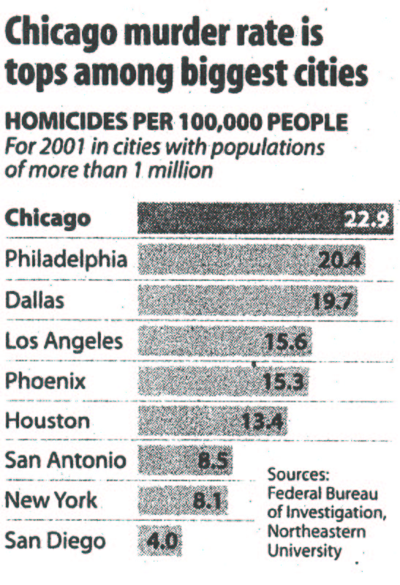

Graph 2

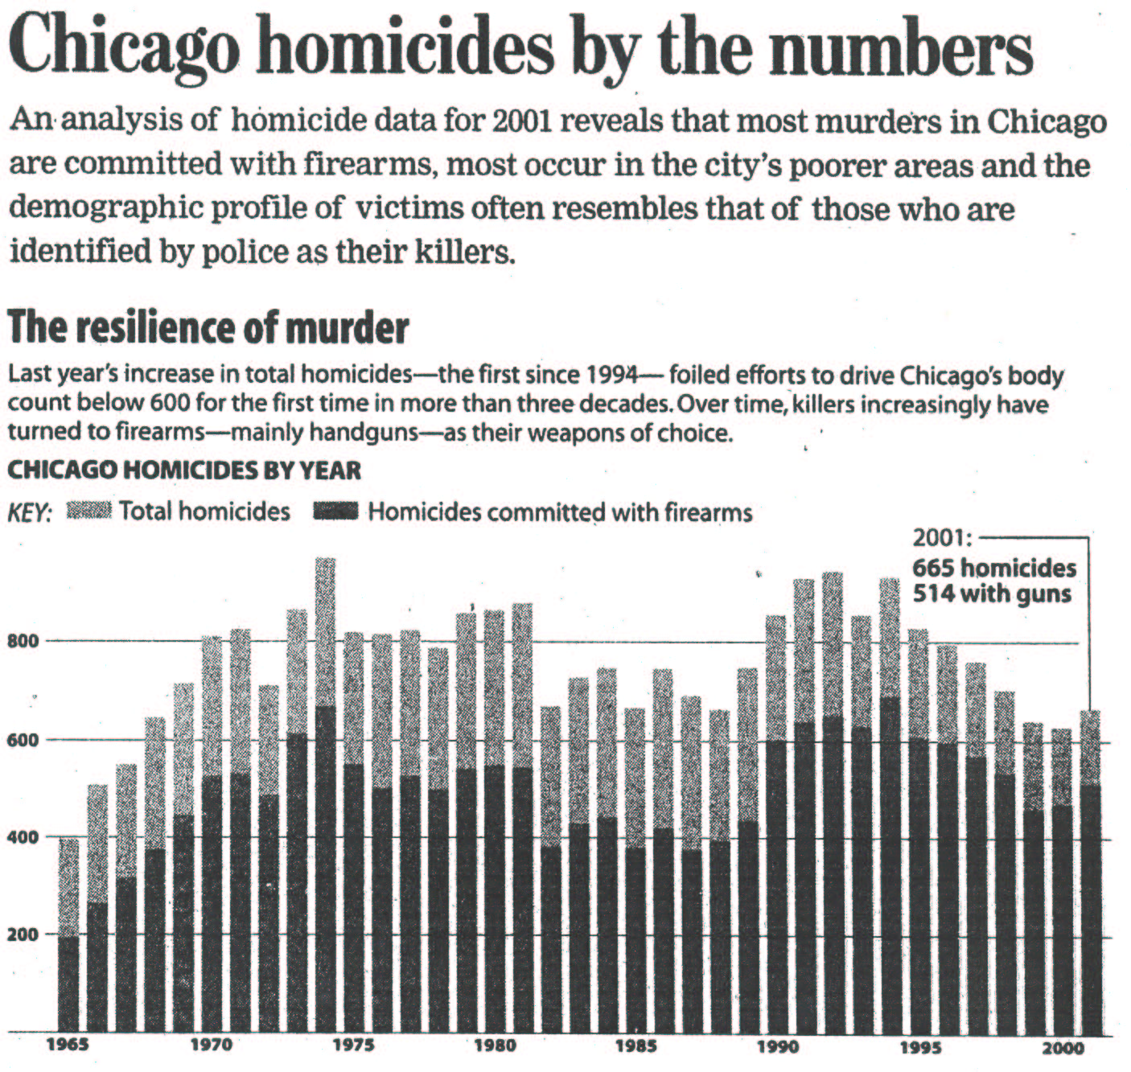

Graph 3

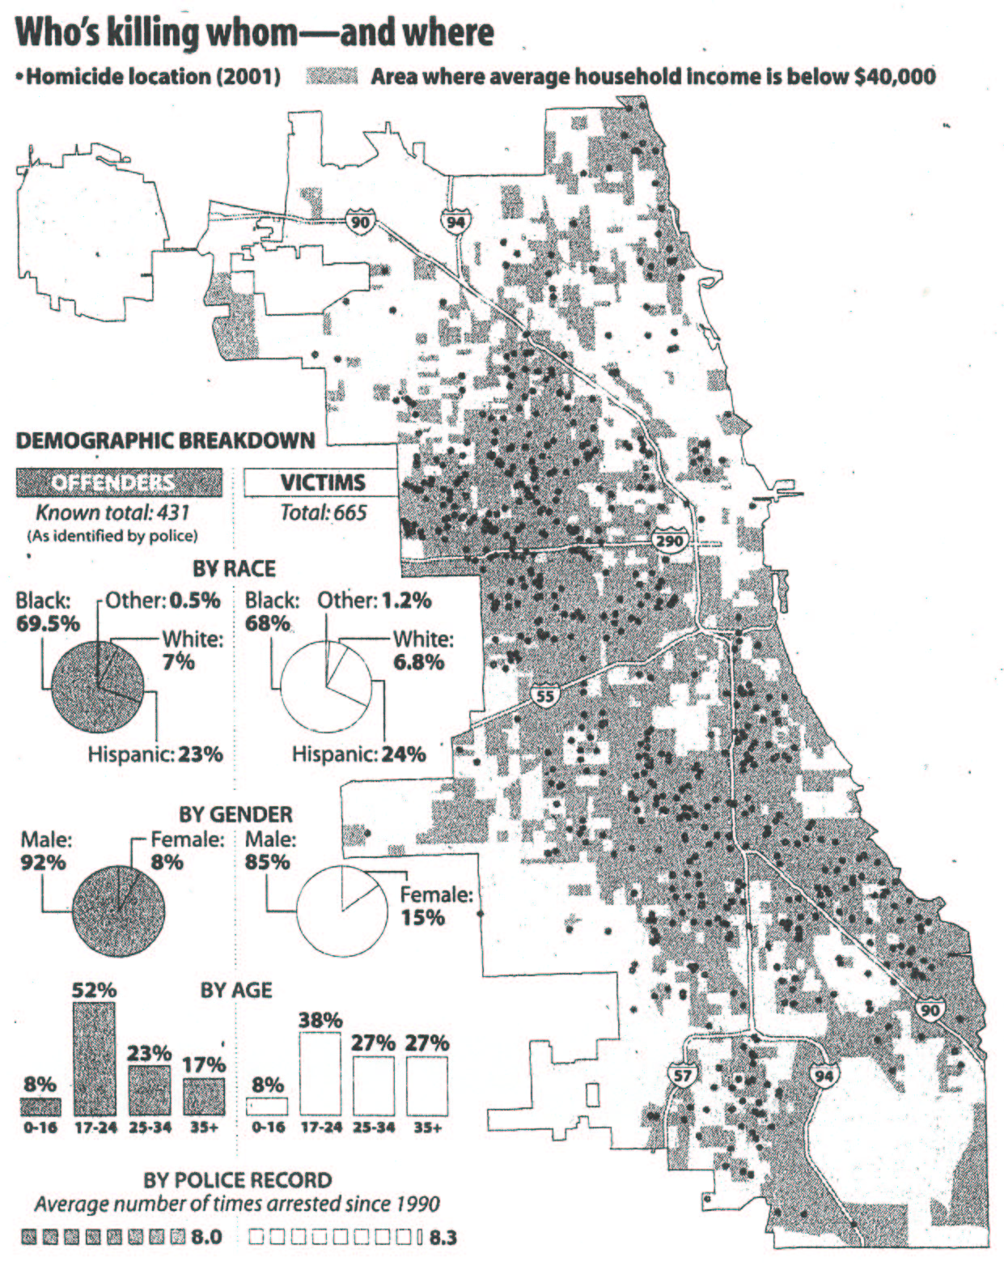

Graph 4

